REPORT ON THE GLOBAL DAY OF ACTION FOR NUTRITION-GHANA COALITION OF SOCIETY ORGANIZATIONS FOR SCALING UP NUTRITION (9TH-11TH MAY, 2014)
- BACKGROUND
This brief report highlights the events that were organized in Ghana to commemorate the Global Day of Action for Nutrition from Friday 9th May 2014 to Sunday 11th May, 2014. Three major events were organized in Ghana to commemorate the Global Day of Action. These are a media engagement to sensitize Ghanaians in general on the importance of nutrition and to inform the public about SUN implementation process in Ghana and to understand their expectations. This was organized on Friday 9th May, 2014 on Home Television (Multi-TV). The second event was a mammoth float that was organized on Saturday, 10th May, 2014 through the principal streets of Accra precisely from Kwame Nkrumah Circle to the Elwak Sports Stadium through the Ring Road. The next event was the thanksgiving service and a prayer session on Sunday 11th May, 2014 at the Amen Amen Institute, Accra. Amen Amen Instiute is a regious organization that continues to pray for world peace and end of hunger and malnutrition in this world. It is an active member of the Civil Society Platform in Ghana.
- NUTRITION AWARENESS CREATION THROUGH THE ENGAGEMENT WITH THE GHANAIAN MEDIA
The Ghana Civil Society Platform for SUN used its media engagement on nutrition as an instrument to create awareness about nutrition and the SUN Movement as part of the events that were initiated to commemorate the Global Day of Action on Friday 9th May 2014. Although the Civil Society Platform for SUN in Ghana organized Media Practitioners Capacity Building Workshop in August 2013, it was still relevant to continue with the media engagement process to deepen the fruitful and solid relationship between Press Houses in Ghana and the SUN CSOs Platform and to further project nutrition and the activities of the National SUN Movement through the media. In Ghana, it is the Media Houses that shape public opinion and so this was an opportunity to consolidate the progress that SUN CSOs in Ghana has achieved in its media relations since 2013. The main objective therefore was to use the media platform to disseminate important nutrition messages to over one million Ghanaians this year on the GDA. The programme entailed a panel discussion on various sensitive topics related to nutrition and national development as well as the activities of the National SUN Movement. It entailed a panel discussion made up of two Panel members and a Moderator. Various listeners phoned into the programme ans asked important questions. The programme was well moderator.
At the end of the panel discussion, it was envisaged that many Ghanaians in the various regions that watched the programme had the opportunity to understand Ghana’s scaling up nutrition implementation process and appreciated the value of investing in nutrition for national development. It also promoted behavioural change and instilled a sense of public commitment to nutrition. It was an event that was used to celebrate nutrition and appreciate its essence in national development.

- FLOAT (WALK FOR NUTRITION, WALK FOR LIFE)
The Ghana SUN CSA Platform organized a float on 10th May, 2014 to attract the attention of Ghanaians to nutrition. The float was organized in the streets of Accra to raise the visibility of nutrition in Ghana and to educate the public on healthy eating practices. The float had the theme “walk for nutrition, walk for life”. Participants included members of the Nation SUN platform, UN Officials, Government Officials, Clergy, Students, youth groups, keep fit clubs, members of the SUN Civil Society Platform and members of the public. There were nutrition messages displayed by the floaters to create public awareness about nutrition. One hundred (100) placards with different nutrition messages were displayed. The float was attended by more than two thousand (2,000) people and attracted the attention of thousands of Ghanaians. As early as 4:00 am people started converging at the meeting ground and at 9:00 am the float started. With brass band music and sound systems arranged on a long trailer which was decorated with banners and with souvenirs, flyers, heavy presence of the Police to escort the team and ambulance on standby, the float started very well and ended at Elwak Sports Stadium at 12:30pm. It was over 8km walk. Among the dignitaries that gave their goodwill messages were the Deputy Director-General of Ghana Health Service, Dr. Gloria Quansah, Representatives of the Minister of Food and Agriculture, Director of Nutrition at Ghana Health Service, Mrs. Kate Quarshie, Deputy Country Director of World Food Programme Mrs. Magdalena Owusu Moshie, Immediate past Head of the Nutrition Department of Ghana Health Service Mrs. Wilhelmina Okwabi, the Vice Chair of the Ghana SUN Civil Society Platform Dr. Frank Mcavor, the Private Sector Coordinator for SUN in Ghana Mr. Emmanuel Quaye, the Coordinator of SUN CSOs Nana Ayim Poakwah, the President of the Africa Nutrition Society Dr. Francis Zortor and the Founding President of the Amen Amen Institute, Amen Amenreynolds Amen. In our own assessment, the float ended very well. The float was covered by two local FM stations and Daily Graphic which happens to be a national newspaper.
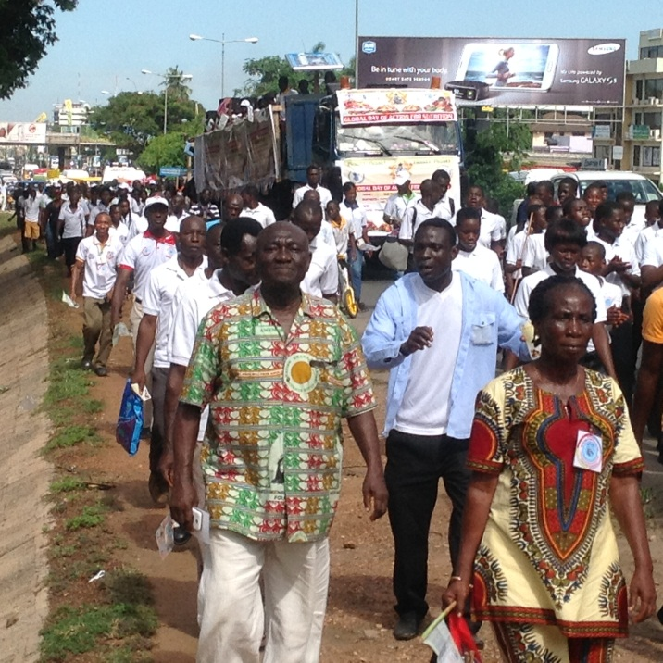
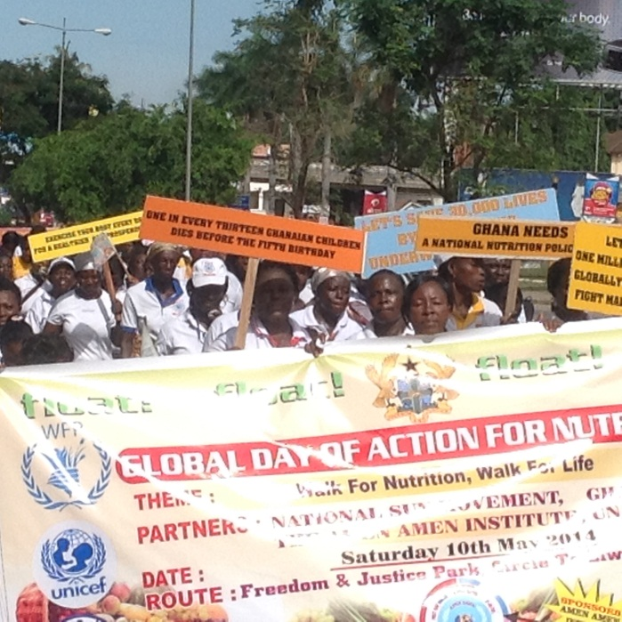
- THANKSGIVING SERVICE AT AMEN AMEN INSTIUTE
There was a thanksgiving service at Amen Amen Institute with over 2,000 members of the institute in attendance on Sunday 11th May, 2014. It was also attended by Nana Ayim Poakwah, the Coordinator of SUN CSOs Platform and the staff at the Secretariat. Amen Amenreynolds Amen and his members prayed for world peace and food security and thanked the Almighty God for the Global Day of Action. Nana Ayim later addressed the members of the Institute to continue to support nutrition and food security in Ghana and continue to play active role in the SUN CSOs platform. The service started at 10:00 am and ended at 1:00 pm local time.
- ASSESSMENT
The overall impression of the events in Ghana on the Global Day of Action was very positive. It was a very successful and memorable occasion in Ghana to put nutrition at the centre of public attention and raised its visibility in Ghana. Though there were a few logistical challenges initially, it all turned up to be very successful. Lessons were learnt and recommendations were made. This will further guide the organization of such events next year.

