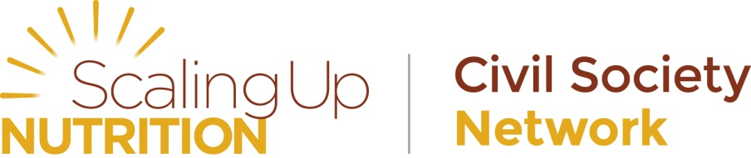
Disclosure Form
Membership application to the Civil Society network of the SUN movement

Organisations applying for membership to the SUN Civil Society Network should also complete and get organisation official to sign the below disclosure form.
The applying organisation is in charge of ensuring the disclosure form is accurate and complete.
It is also the responsibility of the applying organisation to ensure there is a process for internal regular review of commitments and disclosure as well as periodic updates of disclosure forms on an annual basis.
The SUN CSN will not be responsible for incorrect information submitted or for updating out of date information.
Disclosure Form for SUN CSN membership application
By applying to join the Civil Society Network of the SUN movement, NAME OF ORGANISATION commit to | Yes | No
Honour commitments made in the membership application forms
BE TRANSPARENT ESPECIALLY ABOUT INTENTIONS AND IMPACT: Stakeholders will engage in transparent behaviour in all interactions within the context of the SUN Movement. Stakeholders also commit to establishing rigorous evaluations of the impacts of collective action and the contributions of individual stakeholders.
BE INCLUSIVE: The SUN Movement is open to all stakeholders that demonstrate their commitment to its goals. Exclusion should be avoided if at all possible.
BE RIGHTS-BASED: All stakeholders are expected to act in accordance with a commitment to uphold the equity and rights of all women, men and children.
BE WILLING TO NEGOTIATE: All SUN Movement stakeholders are responsible for offering coherent and responsive support to national governments as they implement their nutrition policies and plans. Stakeholders will seek to resolve divergences in approach or divergent or competing interests whenever they arise.
BE PREDICTABLE AND MUTUALLY ACCOUNTABLE: All stakeholders are collectively accountable for their joint commitments; they should follow up on these commitments in a predictable way and be mutually accountable for the commitments being delivered as intended.
BE COST-EFFECTIVE: Stakeholders should be guided by available evidence about policies and actions that have the greatest and most sustainable impact for the least cost.
BE CONTINUOUSLY COMMUNICATIVE: All stakeholders are committed to the regular sharing of their intentions, actions, experiences and concerns.
ACT WITH INTEGRITY AND IN AN ETHICAL MANNER THAT ENHANCES THE REPUTATION AND IMPACT OF THE SUN MOVEMENT: Stakeholders should recognize that both personal and institutional conflicts of interest must be managed with the highest degree of integrity.
BE MUTUALLY RESPECTFUL AND SEEK TO EARN THE TRUST OF THOSE WITH WHOM YOU ARE WORKING: Stakeholders make different contributions to the collective effort. Building the trust needed for collaboration requires respect for these differences.
DO NO HARM: All stakeholders are committed to ensuring that all mothers and children everywhere are empowered to realise their right to proper nutrition. Whatever action is being undertaken, the wellbeing of mothers and children at risk of under-nutrition should be the primary consideration. For this reason, the possible negative consequences of all actions should be considered before any action is taken.
Always uphold and respect children's rights.
NAME OF ORGANISATION hereby declare that | Yes | No
An official internal process has been followed in order to apply for this membership.
A particular individual or committee been assigned to maintain the relationship with the SUN CSN
There is a regular review of internal processes to ensure the information provided in the disclosure document is up to date and commit to annual review of information provided for updating the SUN CSN database should this be required.
There is continual monitoring of new legislation that may impact the organisation’s contribution to the network and corresponding disclosure form
Consideration of conflicts of interest issues is an ongoing agenda item in organisation’s contribution to SUN CSN efforts
A risk register been developed and a process been put in place for regular monitoring established with regards to the membership to the SUN CSN.
There are mechanisms to ensure ongoing communication of potential changes in member organisation status in place and clear within the applying organisation
The organisation abides to existing national legal obligations and regulations, and applicable international codes and obligations (including the International Code of Marketing of Breast Milk Substitutes) – please consider this for each of the country in which the organisation is present
The organisation activities respect local cultures
The organisation has and will continue respecting human rights
The organisation has and will continue respecting UN conventions, global treaties, or others
The organisation is not associated with activities of human trafficking
The organisation is not associated with activities or partnerships they feel should be declared. If so, please list. (for example, an organisation should declare any association with or affiliation to businesses potentially violating the BMS code of conduct in certain countries).

By becoming a member, the organisation understands it does not have decision-making power, which remains bound to the Steering group of the network, with guidance from SUN Civil Society Alliances in SUN countries

Date ___________________________________
Organisation representative Name and Position ___________________________________

Signature of organisation representative ___________________________________
Please return completed, validated and signed form by email to sun.csnetwork@savethechildren.org.uk.

