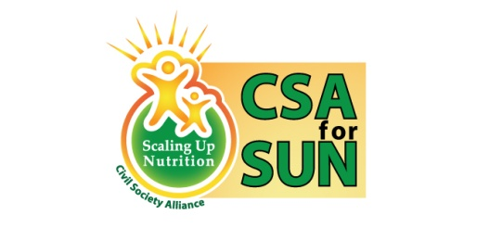 | 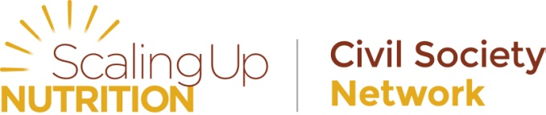
Civil Society Alliance for Scaling Up Nutrition, Bangladesh
Global Day of Action: Acting together for nutrition
Date: 4 May 2014 Venue: Spectra Convention Centre, Dhaka

Background

Civil society groups around the world who are aligned with the Scaling Up Nutrition Movement observed the Global Day of Action (GDA) in the week of 4-11 May, with the aim of showing global support for decisive action to tackle food insecurity and malnutrition. As an Alliance, we must call on our leaders to prioritize the malnutrition issue; on the other hand, citizens must be empowered to engage directly in setting priorities in order to Scale Up Nutrition. 2014 is a key year for ensuring food and nutrition security feature prominently in the post-2015 development framework.

GDA in Bangladesh
Activities for the GDA in Bangladesh were held in two parts: community activities in all 7 divisions of Bangladesh in April 2014, and a national event in the capital city of Dhaka, Bangladesh in May 2014.
Community level activities: April 2014
General Committee members working in 14 different districts across the 7 divisions of Bangladesh organized art and quiz competitions focusing on nutrition, at the community level. The art competition was held among students of class 4, 5 and 6 (9-12 years), with different topics assigned in different regions. Each topic represented the need for multisectoral action on nutrition through some simple messages, such as nutrition for wellbeing, homestead gardening, equal food portions for boys and girls, and hand washing. The winning artwork from all 14 regions were collected and displayed on the day of the national event to portray the multisectoral approaches to nutrition.
Alongside the art competition, a quiz competition was held in the community level for students of class 7, 8 and 9 (13-16 years). The quiz was based on a set of three comic books that focus on the 1000 Days Approach and adolescent nutrition. The comic books were provided to groups of students prior to the competition, which they read before taking part in the quiz. The questions of the quiz were based on the comic books.
CSA for SUN’s brochure as well as information on the Global SUN Movement were also provided to the General Committee members so that they could disseminate these messages amongst parents, guardians, teachers, government officials, civil surgeons, media and other local level influential stakeholders who were present during the art and quiz competition. A special Job Aid on the “1000 Days Approach” created by the Institute of Public Health Nutrition, the technical body under the Ministry of Health and Family Welfare, was distributed among relevant stakeholders who attended the events.
General Committee member organizations who were a part of the CSA for SUN Global Day of Action 2014:
- Poribesh Unnayon Society (Mymensingh, Dhaka)
- Family Ties for Women Development (Kishoreganj, Dhaka)
- Rupantar (Sherpur, Dhaka)
- Unnayan Sangha (Jamalpur, Dhaka)
- Seba Parishad (Sherpur, Dhaka)
- Alliance for Cooperation and Legal Aid Bangladesh (ACLAB) (Chittagong)
- HEED Bangladesh (Sylhet)
- Sylhet Jubo Academy (Sylhet)
- Manob Unnayan Kendra (Khulna)
- Shabolombi (Khulna)
- Voluntary Organization for Social Development (VOSD) (Barisal)
- Anirban Samaj Unnayan Sangstha (ASUS) (Patuakhali, Barisal)
- Prottasha (Pabna, Rajshahi)
- Samajik Kallyan Sangstha (SKS) (Thakurgaon, Rangpur)

National level event: 4 May 2014
The national event which took place in Dhaka involved high level government officials, donor partners, UN bodies, technical community, researchers and civil society as participants. The State Minister of the Ministry of Women and Children’s Affairs Madam Meher Afroz Chumki was present as the Chief Guest. Christa Rӓder, Representative, World Food Programme and Dr. Sultana Khanum, Member of the Global SUN Civil Society Network, were present as the Special Guests. There was an art exhibition featuring the winning artwork from the district level art competitions.
The event commenced with a welcome address by CSA for SUN Chair, Dr. Rukhsana Haider, who outlined the activities of the Global Day of Action in SUN countries with established civil society alliances, and explained the activities that took place in Bangladesh. Dr. Rukhsana Haider also requested the audience to think about what commitments they could make to improve the nutrition situation of Bangladesh, to be shared at the final stage of the event.
After the welcome address, a presentation on the role of civil society in the SUN Movement was made by Mike Foley, Director-Health and Nutrition, Save the Children and Executive Committee member of CSA for SUN. Mr. Foley described CSA for SUN’s activities so far and the responsibility of civil society to highlight the importance of nutrition for the progression of the SUN Movement.
Special guest Dr. Sultana Khanum, Member of the Global SUN Civil Society Network, presented on the Global SUN Movement and the role of GDA as a key input into 2014 regional and global events to exhibit the public pressure for action around nutrition.
Special guest Christa Rӓder, Representative of the World Food Programme, mentioned that she is a programmer, not a nutritionist, but she understands the importance of nutrition and how it can be incorporated in different programmes. She encouraged participants of the event to consider nutrition in programmes outside the health sector for a truly multisectoral approach to nutrition.
Honorable State Minister, Ministry of Women and Children’s Affairs, Madam Meher Afroze Chumki MP, said she dreams of a hunger-free Bangladesh. Bangladesh has been successful in achieving a lot of the Millennium Development Goals, but malnutrition is still prevalent in the country and must be addressed urgently for a healthy and productive Bangladesh. Madam Chumki also added that we must not allow under-nutrition to prevail and it is only possible to overcome malnutrition with coordinated efforts.
Dr. Kaosar Afsana, Director of BRAC’s Health, Nutrition and Population Programme and Secretary of CSA for SUN, thanked everyone for attending the event. The event chair, Dr. Rukhsana Haider, then asked the audience to make commitments for nutrition that could be translated to actions. Participants from each table presented their commitments, as donors, academics, NGO’s and individuals.
CSA for SUN hopes that the Global Day of Action will be an important stepping stone to highlight the nutrition agenda among both leaders and citizens, so that we can unite to end malnutrition.

#ActingTogether4Nutrition
What is your commitment?
ENGAGE • INSPIRE • INVEST
Participants of the national event of the Global Day of Action in Dhaka, Bangladesh, were asked to make realistic commitments which could be translated into actions.
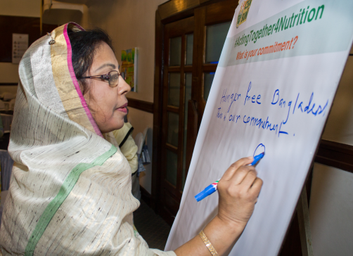 | “Hunger free Bangladesh. This is our Commitment.”  Meher Afroz Chumki MP, State Minister, Ministry of Women and Children’s Affairs, People’s Republic of Bangladesh
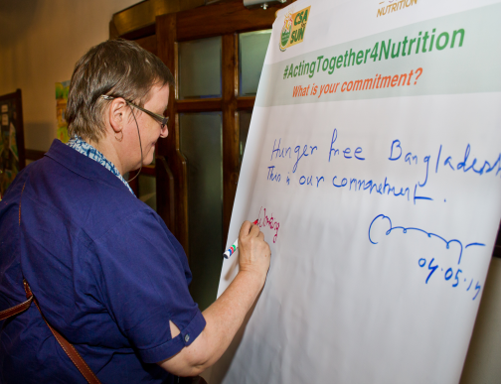 | “Working with the Ministry of Women and Children affairs on mainstreaming nutrition into the VGD program.”  Christa Rӓder, Representative, World Food Programme
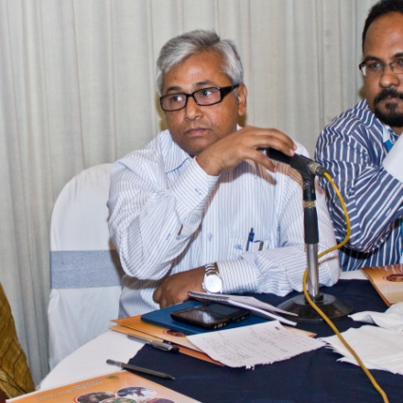 | “I will raise the issue of malnutrition and profile of nutrition in the Prime Minister’s Office, and ensure that Bangladesh speaks loudly on nutrition at ICN-2 and SUN Global Gathering.”  Dr Zulfikar Ali Lenin, Director-Health, Prime Minister’s Office
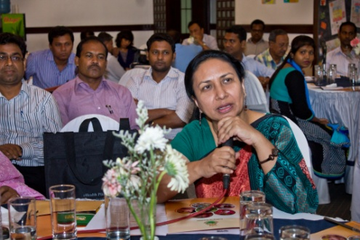 | “We commit to ensuring post-partum Iron Folic Acid and ensuring ante-partum Calcium.”  Dr. Selina Amin, Senior Adviser, MaMoni HSS, Save the Children
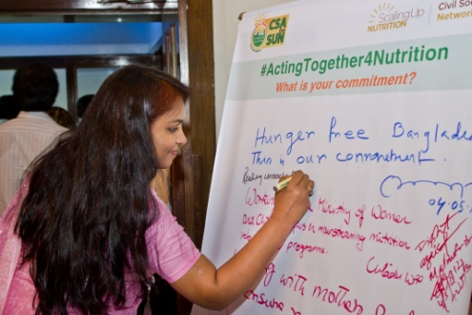 | “Committed to mainstreaming nutrition through direct and sensitive approaches, focusing on availability, utilization and effective coverage for improving nutrition situation in Bangladesh.”  Dr. Fadia Sultana, UNICEF
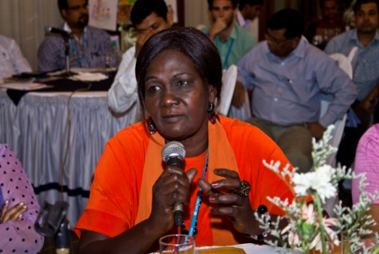 | “WFP commits to DNI in collaboration with other partners and with emphasis on building government capacity (NNS). WFP also commits to ensure all WPP programmes are nutrition sensitive (e.g. including BCC/ nutrition in all programmes).”  Rachel Fuli, World Food Programme
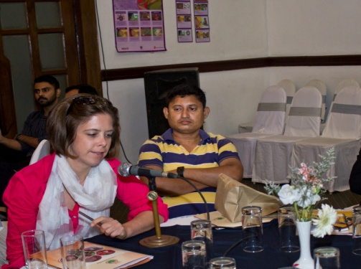 | “UNAIDS is committed to support UN agencies and civil societies in increasing the nutritional support for people with HIV/AIDS to improve effectiveness of treatment.”  UNAIDS
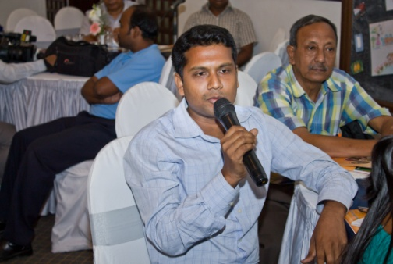 | “We have committed from our organization to improve nutritional status through awareness programs for mother and child.”  TAHN Foundation
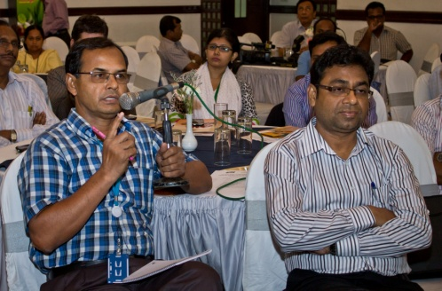 | “UNDP is working with City Corporation and Pourasava. UNDP will try to mobilize Mayors and Pourasava/City Corporation Health Department.”  Md Ruhul Amin, Nutrition Coordinator, UPPR/UNDP
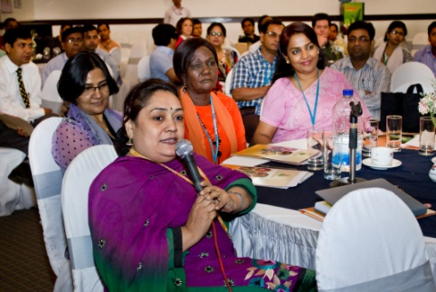 | “We commit to work on prevention and management of malnutrition; to train the health professionals and health personnel on how to manage acute and moderate malnutrition; and to work in collaboration with government and NGO to program activities on micronutrient supplementation of mother and children.”  Dr. Baitun Nahar, ICDDR,B
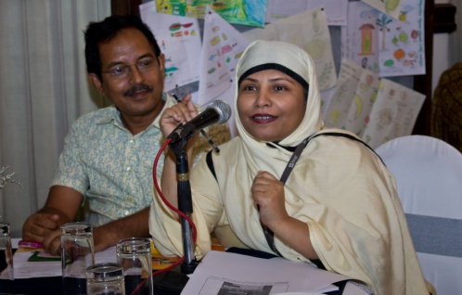 | “On the international month of the Midwife, we commit to carrying the messages of nutrition and the 1000 Days Approach to midwives.”  Dr. Ferdousi Begum, BRAC and CSA for SUN
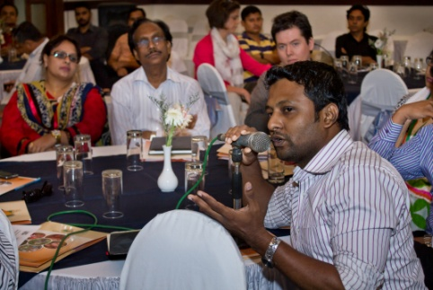 | “We commit to promote nutrition and the 1000 Days Approach on our community radio station.”  ACLAB
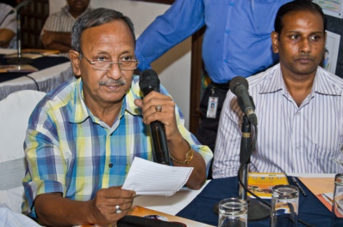 | “VOSD is committed to drive away malnutrition from the country and among the targeted people emphasizing the poor women, adolescents and children, through undertaking intensive and partipative multi-sectoral nutrition promotion programs, advocacy, policy influencing and grassroots level networking.”  Voluntary Organization for Social Development (VOSD)
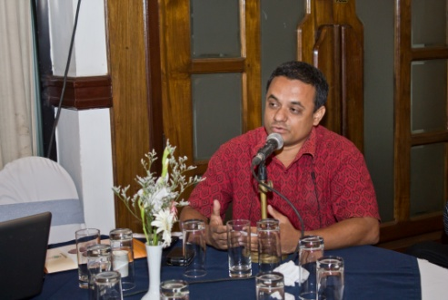 | “In addition to our current activities, we also commit to providing nutritious food to 20 students per year.”  Executive Director, ORNOB
“We commit to increase awareness for purchasing nutritious food.”
Abul Kalam Azad, PROOFS Bangladesh

“We commit to promoting the importance of multisectoral working at all levels, speaking with one common voice on nutrition and increasingly working with media and the youth – through engagement, training and workshops. Nutrition is everyone’s business.”
UN REACH

“We commit to reduce child mortality by raising awareness on nutrition and WASH in our work areas through Student Brigades.”
Executive Director, Prottasha, Pabna

