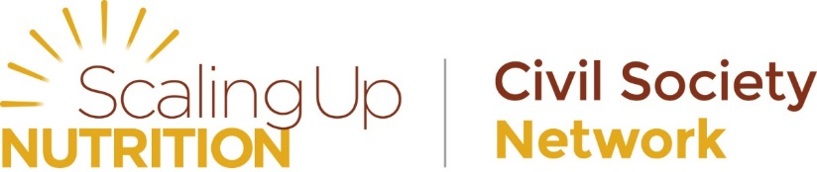

SUN Civil Society Alliances campaign together to put nutrition on the map for global leaders.

In the run up to the Nutrition for Growth: Beating Hunger through Business and Science meeting on the 8th June, SUN Civil Society Alliances have take part in campaign actions around the world.
These actions highlighted to political leaders the importance of investing in nutrition, and were part of efforts happening all around the world as part of the Global Day of Action,
Scaling up Nutrition Civil Society Alliances led campaign efforts in Bangladesh, Ghana, Nepal, Tanzania, Uganda, and Zambia – holding round tables with politicians, public rallies, concerts and debates – all with the aim of asking their own national governments to do what’s necessary to tackle hunger and malnutrition.

Bangladesh
The Civil Society Alliance for Scaling Up Nutrition, Bangladesh, organised a seminar on exploring the opportunities for scaling up nutrition in Bangladesh on Tuesday just days before the June 8 “Nutrition for Growth: Beating Hunger through Business and Science” Summit in London.
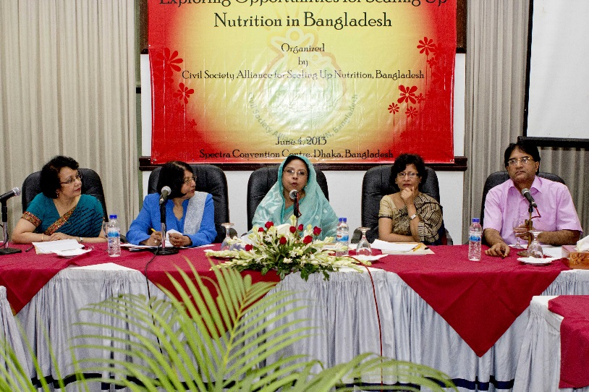
The event was used to advocate to policymakers to incorporate nutritional components in interventions and programmes - especially relating to agriculture, education and health. At the event, CSA representatives distributed symbolic spinning flowers to the participants who wrote nutritional messages in the paper flowers and planted them. The event attracted some good media coverage, as can be seen here.

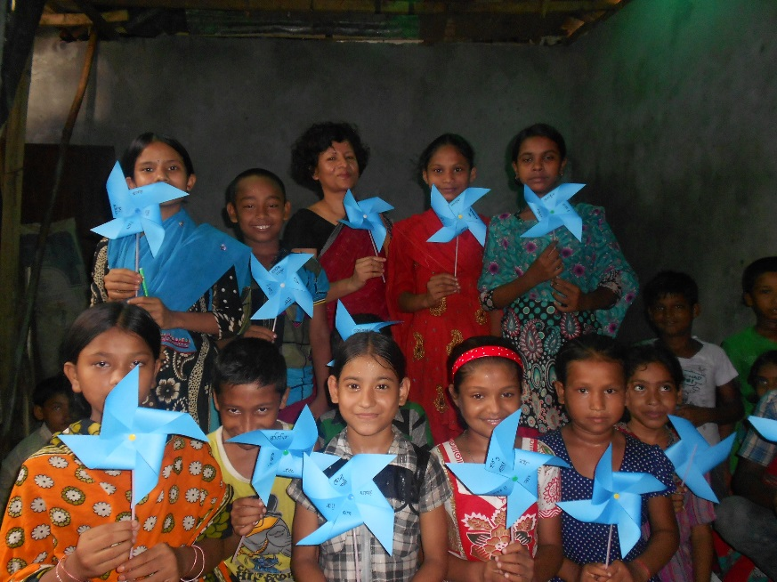

Honourable State Minister for Women and Children Affairs – Ms Meher Afroze Chumki - attended the event, and said: “Women and children are a majority population group and covering two third of country’s population. It is important that their rights to health nutrition and education and social safety are ensured for them to achieve the over all country’s development. If neglected we will miss survival and development of a huge population and the nation”.
She also spoke very positively about the SUN Movement as an opportunity to place nutrition high on the political agenda and to ensure government ownership and leadership to take movement forward.
The CSA for SUN in Bangladesh was formed last year, nearly two years after the global SUN movement to support the national effort to scale up nutrition. It has recently succeeded in setting up a new website, which can be found at www.suncsa.org.

Ghana
The CSOs forum on Scaling Up Nutrition in Ghana held a high-level and extremely well-attended policy debate at the British Council in Accra, Ghana on 5th June.

The event was chaired by Dr. Edith Tetteh, Vice Chairperson, National Development Planning Commission and National SUN Focal Person.
Many high-level participants attended, including several Ghanaian parliamentarians; the Director-General, Ghana Health Service Dr. Appiah Denkyirah; representatives from the Ministry of Food and Agriculture; country representatives from REACH, FAO, USAID; and over twenty national and international civil society organisations working on Nutrition. It also received some excellent media coverage, including on Ghana Television, TV3, the Citizen, Accra Times, and Peace FM.

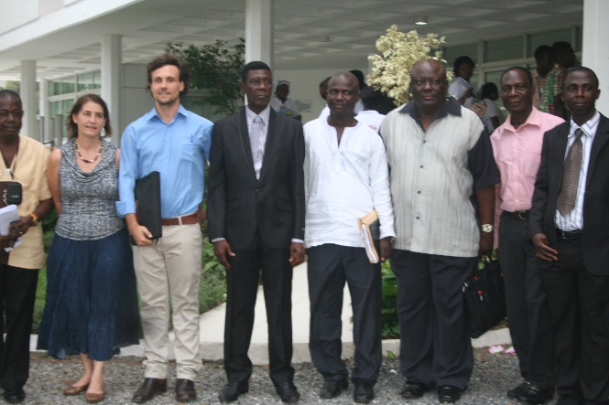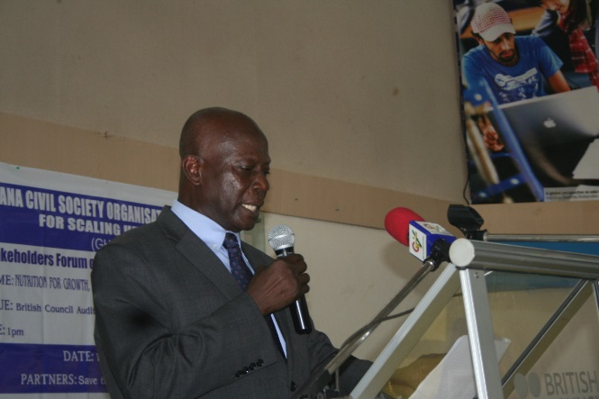

Member of Parliament for Akrofuom and Co-Chair of the Ghana Parliamentarians Against Hunger and Malnutrition, Honourable Kwabena Appiah Pinkrah attended the event. He told participants that the consequence of malnutrition is so devastating that failure to act decisively to reverse the trend means that they as politicians and policy makers are condemning the vast majority of infants and young children into premature death and avoidable diseases.

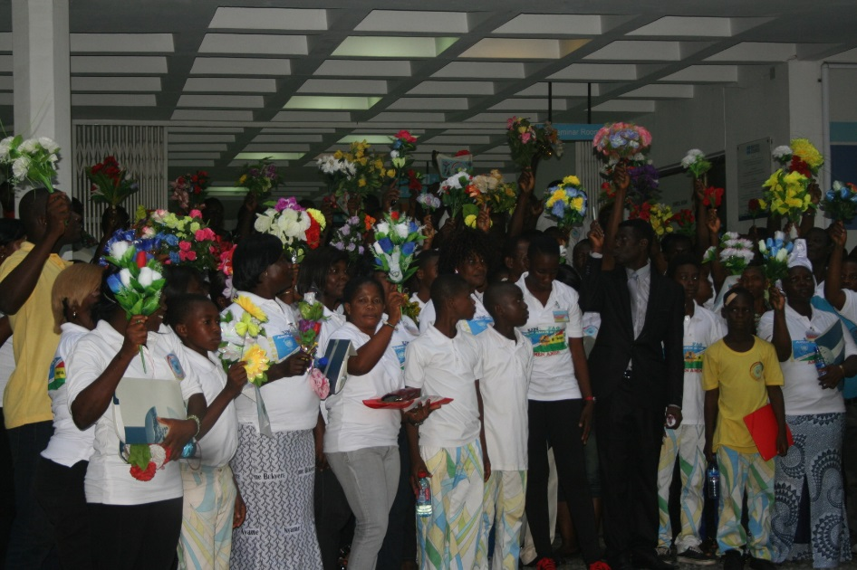
Mrs. Mary Mpereh from the National Development Planning Commission spoke of the need for each sector to play its role, and the importance of Ghana’s Cross-Sectoral Planning Group (CSPG) on Nutrition for coordinating. Nana Ayim Poakwah, Coordinator of Ghana Civil Society Organizations for SUN spoke at the event about the need to mobilize public support for action to scale up nutrition, and stated that the Government of Ghana needed to develop and deliver proven nutrition-specific and nutrition-sensitive interventions, based on a sound, effective legal, policy and institutional framework within a three-year period.

Nepal
The SUN movement in Nepal, led by the Nepal Nutrition Foundation (NNF) organized an interaction meeting in Kathmandu, involving nutritionists, medical doctors, and other professionals.
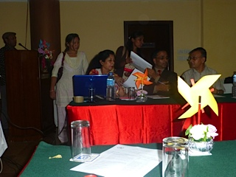
The theme of the interaction program was “SUN Movement with Food for Everyone.” The Chairperson of NNF, Dr. Uma Koirala, expressed the relevancy of SUN in Nepal, and then Member Secretary of the National Planning Commission Dr. Yubaraj Bhusal highlighted the efforts done by the government of Nepal in the nutrition sector with changing the behaviour of the Nepalese people in food intake, and its accessibility and affordability.

The meeting successfully gave the message of nutrition interventions that were introduced from different government and non-government agencies. Further, it could create awareness of the civil society in respect to the concepts of SUN. The interaction was fruitful, raising interest and commitment from all participants to further contributions related to nutrition in Nepal. Highly recommended was to continue the establishment of such gatherings/interactions in the future, to strengthen the SUN movement’s objectives.

Tanzania
Tanzania’s SUN civil society coalition, PANITA, held a huge event with 2600 children all holding spinning flowers. The event was also attended by young reporters, officials, youth council members, journalists and mass public.
The event took place weeks after the President called for action to accelerate the implementation of the National Nutrition Strategy (16th May)
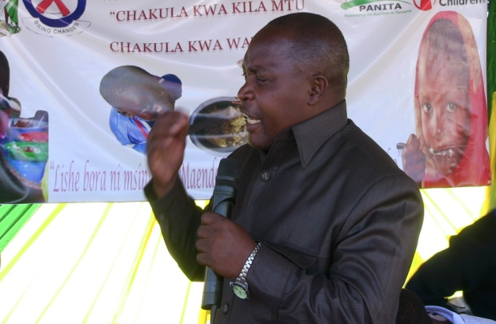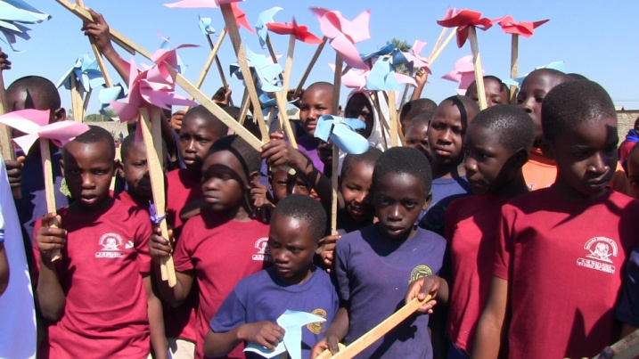

Uganda
The Uganda Civil Society Coalition on Scaling Up Nutrition (UCCO-SUN) organised several events as contributions towards the Global Day of Action Activities.
On June 6th, it organised several policy-makers to come together to discuss important issues around nutrition in Uganda.

The half day dialogue was moderated by Baguma Richard, the Coordinator of Uganda Health Communication Alliance, a member organisation of UCCO-SUN, who spoke of the “need to talk of nutrition issues as everyday issues”. Other speakers included Kato Petersen, Muniirah Mbabazi, and Peter Rukundo of Kyambogo University.
UCCO-SUN released a statement calling on the Government of Uganda to “increase the health budget allocation from the persistent 9% to 15% of the total national budget in the FY 2013/14 as per the Abuja Declaration” and to “prioritise investment in implementation the Uganda Nutrition Action Plan”.
The dialogue was widely covered in the media, including in The New Vision, Daily Monitor, The Observer, CBS FM, Capital FM, Prime Radio, Voice of Africa, Urban TV, Record TV, UBC TV among others.
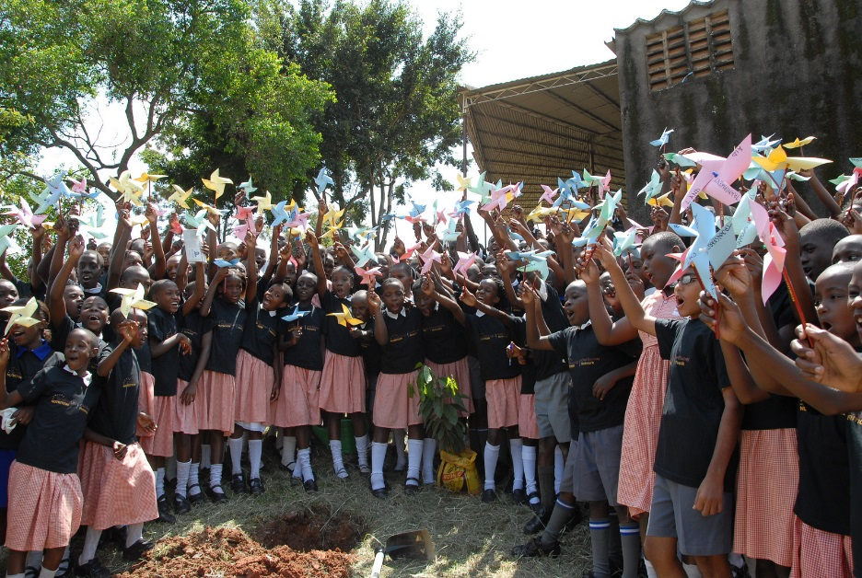
On June 8th, UCCO-SUN organised a mass rally outside of Uganda’s national museum, featuring over 200 children from local schools. Members of UCCO-SUN visited one of the remotely located schools Kisimbiri Primary School in Wakiso district. Twalabye Beatrace , the Head Mistress Kisimbiri Primary School said more than 70% i.e. 782 of the 1000 pupils in the school go without lunch. “Some come from child headed families that find it hard to avail food for the children,” she added.
Nutricare Uganda served Soya porridge to the entire school, which left the children very happy. Gumisiriza Reuben, the Transport Manager of Nutricare Uganda said that the Organization operated in Bananya and Kisimbiri primary schools where they offer nutritious porridge and firewood that is used to cook it.

At the end of the event, the children raised flowers to support and raise attention to the 200 children who die daily from nutrition related causes. The event was covered by UBC TV, CBS and Bukkedde radios.

Zambia
The Zambian CSO-SUN Alliance held a ‘Nutrition for Development Concert’ on June 8th in the Barclays Sports Complex in Lusaka. The event was a huge success and as many as 1000 people were estimated to attend.
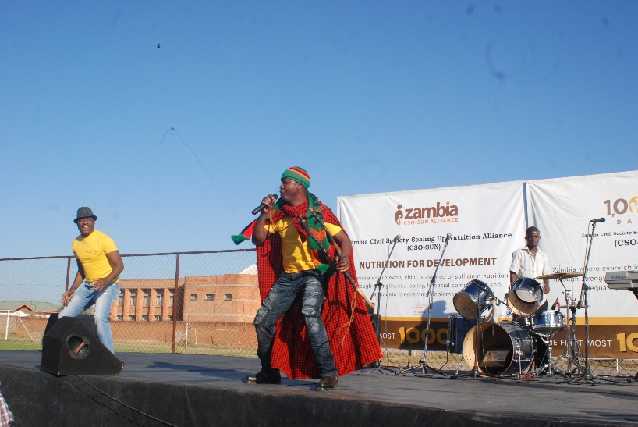
The concert received much visibility, with the performing artists spending the days before the event presenting key messages about nutrition on many of the main radio stations’ breakfast- and lunch-time shows.

