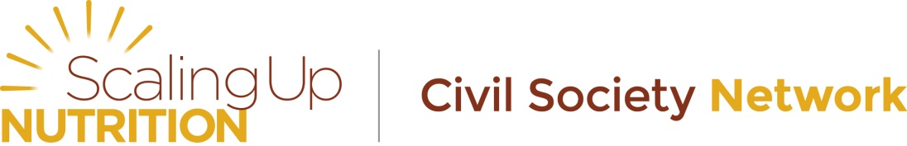
Membership Strategy of the
Civil Society Network of the Scaling Up Nutrition Movement (SUN CSN)

Civil society organizations collectively have a very powerful voice and can provide grass-roots / community-driven support for scaling up nutrition locally.

SUN Civil Society Network (SUN CSN)
The SUN Civil Society Network (SUN CSN) was established to support the formation and evolution of Civil Society Alliances in SUN countries, as well as facilitate communication and coordination across SUN CSAs, and with the broader SUN Movement.
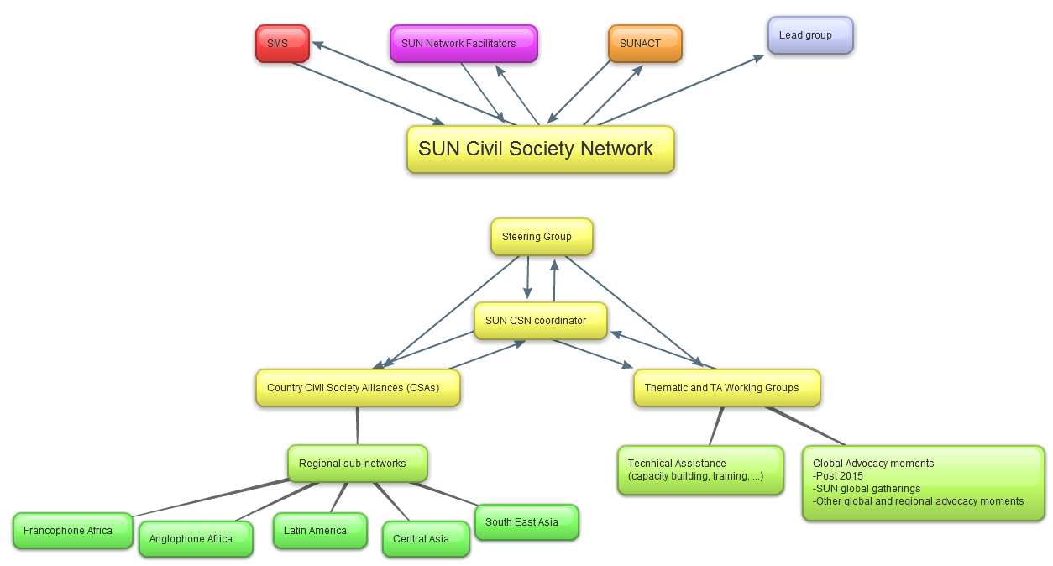
SUN CSN governance structure

Purpose of the network
The primary purpose of the SUN Civil Society Network (SUN CSN) is to encourage the alignment of Civil Society Organisations’ (CSO) strategies, programmes and resources with country plans for scaling up nutrition. The CSN aims to achieve this through strengthening the support available for and capacity of, national Civil Society Alliances (CSA). It is responsible for encouraging effective engagement from civil society in the SUN process at national and global levels and supports CSAs in SUN countries to advocate for the development of ambitious plans. It also contributes to the implementation and rolling out of national costed plans and the monitoring of the delivery of those plans.

Focus
Provide support to in-country efforts.

Current membership
The Civil Society Network is made up of representatives from each of the active SUN National CSAs facilitated by a Steering Group and a Network Coordinator. National SUN CSAs represent several hundreds of national, regional and international organisations and networks working in various areas including: small-hold farmers, fisherfolk, human rights defenders, women’s groups, humanitarian and aid assistance agencies, advocacy and research entities, consumer groups, trade unions and many others, actively engaged in scaling up nutrition in their countries. Organisations within the Network are working together to build capacity and maximise resources to ensure the greatest impact on nutrition.

Who can be a member
Following the principle of inclusiveness of the SUN movement, membership is open to any civil society organisation and institution wanting to link with the SUN Civil Society Network (CSN). Joining the network should however be an institutional choice and not an individual one. Organisations already member of another network of the SUN movement will not be eligible for SUN CSN membership. By becoming a member, you commit to actively contribute to the objectives of the SUN.
Individuals interested to follow SUN CSN efforts are welcome to become friends of the network to follow our efforts and receive regular progress updates.
Decision-making for the SUN CSN remains bound to the Steering group of the network, with guidance from SUN Civil Society Alliances in SUN countries.

SUN CSN partners
The SUN CSN will also develop relationships with other non-member partners to support the network’s efforts and share experiences.

Guiding principles
By joining the network, members commit to embracing and adhering to the SUN Principles of Engagement. These principles should inform and guide all aspects of the life of the SUN CSN both at the global level and in countries.

Joining statement and commitments
Upon joining the network, organisations will provide a short description of what they are planning to bring to the network.

Examples of type of support organisation can commit to bringing
We understand that not all organisations have the possibility to bring resources to the network. However, below are examples of the type of support you could commit to provide if your organisation is able to do so.
- Coordinate and /or provide access to technical support forums / online question and answers spaces;
- Upload specific tools and resources – guidance notes, existing guides, tool kits, training materials, advocacy materials
- Provide access to and/or support attendance of SUN CSA representatives to training opportunities,
- Organise / contribute expertise at webinars (around specific topics to be recorded and available offline)
- Provide translation support (simultaneous translation at events, translation of key materials, language dialogues, capacity building strategy dimensions in various languages)
- Facilitate documentation of country experiences
- Specific ways to strengthen capacity for CSAs to contribute to ensuring efforts happen at the district level
- Leveraging technical assistance in SUN countries, etc…

Process for becoming a member
- Express interest in becoming a member by completing forms in Annex 1, Annex 2 and registration sheet, signed by the responsible person in your organisation and return to sun.csnetwork@savethechildren.org.uk.
- Membership requests will then be reviewed by the SUN CSN secretariat to ensure in compliance with SUN principles, as per disclosure form completed, and taken to the Steering Group of the SUN CSN, or appropriate committee should membership expand rapidly. Should an applying organisation not be compliant with SUN principles, application will become ineligible for membership. However, the organisation could still be considered as a friend of the network and kept informed of the SUN CSN activities and is entitled to apply for membership to the network at a later stage once any potential conflicts of interests / non-compliance have been resolved.
- Should objections be expressed, the membership request will be taken to a voting stage from the SUN CSN Steering Group members.

Process for becoming a friend
- Express interest in becoming a friend of the network by contacting us at sun.csnetwork@savethechildren.org.uk.

What being a member of the SUN CSN means for YOUR organisation
1. A monthly update of the SUN CSN activities
2. Access to a number of resources to support in country efforts (documents from other SUN CSAs to guide your efforts, portal to key tools and resources and access to SUN CSN specific tools and resources)
3. Being part of the SUN movement
4. Being part of a community of stakeholders engaged in addressing malnutrition from the bottom-up
5. Being part of coordinated and harmonised advocacy efforts
6. Being able to take part in cross-learning efforts and improving your own practice from lessons learnt
7. Contributing to a Global Day of Action during which you commit to engaging in and organising events, activities and other efforts for addressing malnutrition whatever the focus of YOUR organisation is, as part of the SUN civil society network efforts, once a year.
8. Opportunities to influence global directions in nutrition through advocacy efforts at key global and regional moments (post-2015, Road to Rio, International Year of Family Farming)
9. Participation in key SUN events (through open nominations process and within limited funding available, with priority given to country SUN CSA representatives)
10. Being part of thematic and / or technical assistance working groups
11. Cross-linking websites – improved visibility of your organisation’s efforts.
What can YOUR organisation CONTRIBUTE to the SUN CSN
1. Expertise in a specific area
2. Technical Assistance for in-country efforts
3. Contribute to shaping and implementing the SUN CSN’s capacity building strategy
4. Provide opportunities, when possible, for expanding the network and supporting its effective functioning and implementation of its various strategies to ultimately ensure we reach the communities that are suffering from malnutrition in SUN countries.
5. Cross-linking website – improved visibility of SUN CSN efforts.

It is important to note that joining the network will not give you access to financial resources. The SUN CSN has very limited resources and is always looking for additional support to be able to more effectively function and implement its various strategies and activities.

Annex 1 - Membership form
Name of organisation:

Details and description of organisation:

Organisation website:

Organisation representative and contact details (name, physical address, email address, skype, telephone and fax):

Statement
By joining the SUN Civil Society Network, NAME OF ORGANISATION commits to (in no more than 200/300 words) – Commitments should be expressed in terms of concrete actions (staff time dedicated, expertise provided, alignment at country level and what this looks like, translation of key documents, hosting language dialogues, etc…)::

* Please confirm you have completed corresponding xls registration sheet and that this sheet is attached by ticking this box □
* Please confirm you are happy for the SUN CSN secretariat to manage your contact details and use for SUN CSN related efforts.
□ Yes I am happy for SUN CSN to manage my organisation’s contact details and use for SUN CSN related efforts, including posting on SUN CSN web page.
□ Yes I am happy for SUN CSN to manage my organisation’s contact details and use for SUN CSN related efforts, but please consult me before posting on SUN CSN web page.
□ No, I would prefer the SUN CSN secretariat did not use for SUN CSN related efforts without prior notification.
** Please note that by becoming a member you also commit to reporting on the commitments and related efforts to the SUN CSN secretariat at least on a bi-annual basis, and more often if required.

Date ___________________________________
Organisation representative Name and Position ___________________________________

Signature of organisation representative ___________________________________

Please return completed, validated and signed form by email to sun.csnetwork@savethechildren.org.uk.

Annex 2 – Disclosure form for applying members
Organisations applying for membership to the SUN Civil Society Network should also complete and get organisation official to sign the below disclosure form.
The applying organisation is in charge of ensuring the disclosure form is accurate and complete.
It is also the responsibility of the applying organisation to ensure there is a process for internal regular review of commitments and disclosure as well as periodic updates of disclosure forms on an annual basis.
The SUN CSN will not be responsible for incorrect information submitted or for updating out of date information.
Disclosure Form for SUN CSN membership application
By applying to join the Civil Society Network of the SUN movement, NAME OF ORGANISATION commit to | Yes | No
Honour commitments made in the membership application forms
BE TRANSPARENT ESPECIALLY ABOUT INTENTIONS AND IMPACT: Stakeholders will engage in transparent behaviour in all interactions within the context of the SUN Movement. Stakeholders also commit to establishing rigorous evaluations of the impacts of collective action and the contributions of individual stakeholders.
BE INCLUSIVE: The SUN Movement is open to all stakeholders that demonstrate their commitment to its goals. Exclusion should be avoided if at all possible.
BE RIGHTS-BASED: All stakeholders are expected to act in accordance with a commitment to uphold the equity and rights of all women, men and children.
BE WILLING TO NEGOTIATE: All SUN Movement stakeholders are responsible for offering coherent and responsive support to national governments as they implement their nutrition policies and plans. Stakeholders will seek to resolve divergences in approach or divergent or competing interests whenever they arise.
BE PREDICTABLE AND MUTUALLY ACCOUNTABLE: All stakeholders are collectively accountable for their joint commitments; they should follow up on these commitments in a predictable way and be mutually accountable for the commitments being delivered as intended.
BE COST-EFFECTIVE: Stakeholders should be guided by available evidence about policies and actions that have the greatest and most sustainable impact for the least cost.
BE CONTINUOUSLY COMMUNICATIVE: All stakeholders are committed to the regular sharing of their intentions, actions, experiences and concerns.
ACT WITH INTEGRITY AND IN AN ETHICAL MANNER THAT ENHANCES THE REPUTATION AND IMPACT OF THE SUN MOVEMENT: Stakeholders should recognize that both personal and institutional conflicts of interest must be managed with the highest degree of integrity.
BE MUTUALLY RESPECTFUL AND SEEK TO EARN THE TRUST OF THOSE WITH WHOM YOU ARE WORKING: Stakeholders make different contributions to the collective effort. Building the trust needed for collaboration requires respect for these differences.
DO NO HARM: All stakeholders are committed to ensuring that all mothers and children everywhere are empowered to realise their right to proper nutrition. Whatever action is being undertaken, the wellbeing of mothers and children at risk of under-nutrition should be the primary consideration. For this reason, the possible negative consequences of all actions
Always uphold and respect children's rights.

NAME OF ORGANISATION hereby declare that | Yes | No
An official internal process has been followed in order to apply for this membership.
A particular individual or committee been assigned to maintain the relationship with the SUN CSN
There is a regular review of internal processes to ensure the information provided in the disclosure document is up to date and commit to annual review of information provided for updating the SUN CSN database should this be required.
There is continual monitoring of new legislation that may impact the organisation’s contribution to the network and corresponding disclosure form
Consideration of conflicts of interest issues is an ongoing agenda item in organisation’s contribution to SUN CSN efforts
A risk register been developed and a process been put in place for regular monitoring established with regards to the membership to the SUN CSN.
There are mechanisms to ensure ongoing communication of potential changes in member organisation status in place and clear within the applying organisation
The organisation abides to existing national legal obligations and regulations, and applicable international codes and obligations (including the International Code of Marketing of Breast Milk Substitutes) – please consider this for each of the country in which the organisation is present
The organisation activities respect local cultures
The organisation has and will continue respecting human rights
The organisation has and will continue respecting UN conventions, global treaties, or others
The organisation is not associated with activities of human trafficking
The organisation is not associated with activities or partnerships they feel should be declared. If so, please list. (for example, an organisation should declare any association with or affiliation to businesses potentially violating the BMS code of conduct in certain countries).

By becoming a member, the organisation understands it does not have decision-making power, which remains bound to the Steering group of the network, with guidance from SUN Civil Society Alliances in SUN countries

Date ___________________________________
Organisation representative Name and Position ___________________________________

Signature of organisation representative ___________________________________
Please return completed, validated and signed form by email to sun.csnetwork@savethechildren.org.uk.

http://scalingupnutrition.org/about/principles-of-engagement

